PRD: Resume–Job Description Gap Analyzer (PWA + Chrome Extension)
Nov 10, 2026 · @Abhijith

Overview
This product shows a job seeker exactly what is missing from their resume for one specific job description, and what to write to close each gap. It runs entirely in the user's browser, using the user's own AI API key. ("ResumeFit" is a working name.)
Problem. Tailoring a resume to each posting means reading the job description, rereading the resume and guessing what to change. It is slow, and people skip it or miss key requirements.
Solution. A Chrome extension captures the job description from any job page and sends it to a local Progressive Web App (PWA). The PWA holds the user's resumes, compares them against the job description with an LLM, and returns a gap report with concrete rewrite suggestions.
Main outcome. For each (job description, resume) pair, the user gets a list of gaps and the suggested wording to add or change so the resume matches the role.
Product principles.
- Local-first: resumes, job descriptions and results stay in the browser's IndexedDB; there is no backend in v1.
- Bring your own key: the user pays their own LLM provider and can see exactly what each request cost in tokens.
- Capture where the job is, review where there is room: the extension is thin; the PWA is the workspace.

Goals, non-goals and success metrics
Goals
- Turn any job posting into a structured job description in two clicks from the extension.
- Compare a chosen resume (PDF or DOCX) against it and list gaps with specific rewrite suggestions.
- Keep all user data on the device and make every token spent visible.
- Work offline for everything except the LLM call.
Non-goals for v1
- No accounts, cloud sync or backend server.
- No job search, job board or application tracking.
- No hosted LLM or shared API key; the user always brings their own.
- No live resume editor yet (planned for a later phase, see Roadmap).
Success metrics (proposed, to confirm)
Metric | Target
Time from clicking Capture to a finished gap report | Under 60 seconds for a one-page resume
Captures that yield a usable job description | At least 90% on the 5 largest job sites tested
Suggestions the user keeps or copies into their resume | At least 50%
Token cost per comparison, shown to the user | 100% of requests logged in the usage page

Target users and use cases
The primary user is a technically comfortable job seeker who applies to many roles, already has an API key for Claude, GitHub Copilot or a similar provider, and cares about keeping personal documents off third-party servers.
Use case | What the user does | What they get
Tailor to one posting | Opens a job page, clicks Capture, picks a resume | Gap report with suggested wording
Compare several resumes | Runs the same job description against 2 or 3 stored resumes | Which resume fits best and why
Revisit a past analysis | Opens the PWA history | Saved job descriptions and reports, no new tokens spent
Watch spend | Opens the usage page | Tokens and cost per request, per model, per day
Edit a resume to fit (future) | Applies a suggestion inside the PWA | Updated resume version, saved locally

End-to-end user flow
The extension starts each run, the PWA does the work, and the user's own API key pays for the LLM call. The user can follow progress in the popup and read the full result in the PWA.
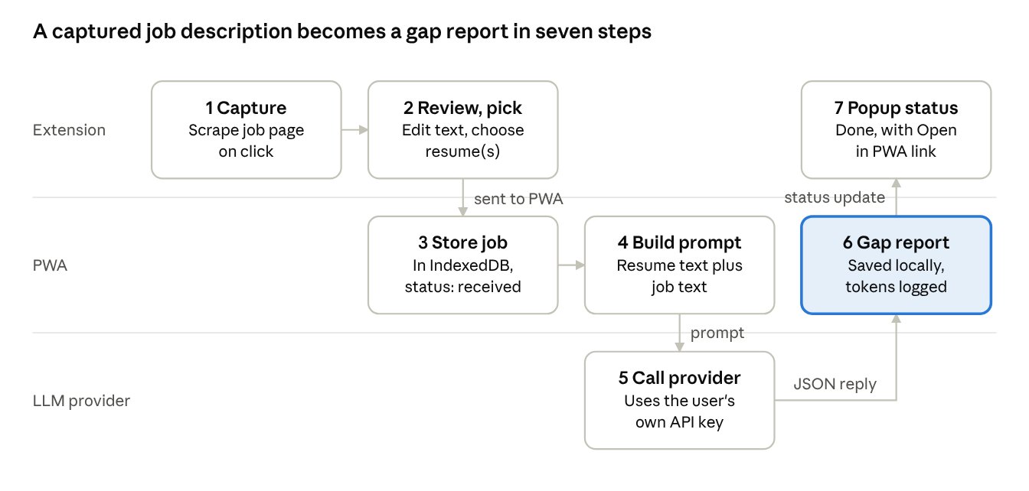
user flow · 7 steps across extension, PWA and LLM provider
The highlighted step is the main outcome: a saved gap report the user can reopen without spending more tokens.

Functional requirements
Priority: P0 = needed for MVP, P1 = v1, P2 = later.
A. Chrome extension
ID | Requirement | Priority
E1 | Capture button extracts the visible job description: title, company, location, body text, source URL | P0
E2 | Show the extracted text in a popup so the user can fix or trim it before sending | P0
E3 | Detect whether the PWA is open and reachable; if not, show a link to open it | P0
E4 | Send the captured job description to the PWA | P0
E5 | List the resumes stored in the PWA and let the user pick one or more | P0
E6 | Show live status in the popup: captured, sent, comparing, done or failed | P0
E7 | Show a short comparison summary (match score, top gaps) with an Open in PWA link | P1
E8 | Site-specific extractors for the largest job boards, with a generic fallback | P1
B. Progressive Web App
ID | Requirement | Priority
W1 | Installable and works offline for everything except LLM calls | P0
W2 | Upload PDF and DOCX resumes, parse them to text, store the original file and the parsed text | P0
W3 | Resume library: list, rename, delete, set a default | P0
W4 | Inbox of captured job descriptions with status (received, analysing, done, failed) | P0
W5 | Comparison view: match score, missing keywords and skills, weak sections, suggested rewrites per gap | P0
W6 | History of all comparisons, reopenable without new LLM calls | P0
W7 | Settings: provider, API key, model, export and delete all data | P0
W8 | Export a report as Markdown or PDF | P1
C. Comparison engine
- Input: parsed resume text and the job description text.
- Output (structured JSON, validated before display): overall match score, requirements met, requirements missing or weak, keyword gaps, and for each gap a suggested resume line plus the resume section it belongs in.
- Suggestions must be grounded in what the resume already says; the engine flags anything the user would need to confirm is true rather than inventing experience.
- Long inputs are chunked or trimmed with a visible warning.
D. Bring-your-own-key LLM access
- Provider abstraction with Claude (Anthropic API) first, then others the user may hold (GitHub Copilot or OpenAI-compatible endpoints). The exact access route for each provider needs checking, since not every subscription exposes a key usable from a browser. See Open questions.
- Key entered once in Settings, stored on the device only, never sent anywhere except the chosen provider.
- Clear error messages for invalid key, rate limit and quota problems.
E. Usage statistics page (P1)
- One row per LLM request: time, provider and model, purpose (comparison, later rewrite), input tokens, output tokens, estimated cost, linked job description and resume.
- Totals by day, week, model and purpose; filter by date range.
- Token counts come from the provider's response; cost uses a price table the user can edit.
F. Live resume editing (future, P2)
- Apply a suggestion with one click to a working copy of the resume, with the original kept.
- Side-by-side diff of resume versions; version history in IndexedDB.
- Export the edited resume as DOCX or PDF.

Architecture and data model
The PWA owns all data and logic. The extension only captures a job description and relays messages, so it stays small and holds no secrets.
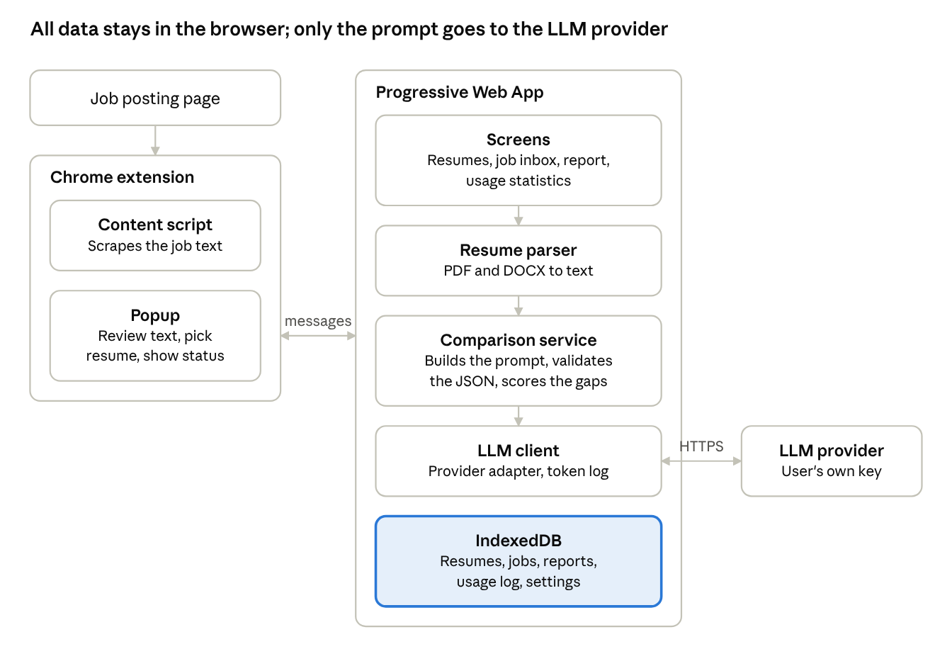
architecture · extension, PWA, IndexedDB, LLM provider
The only outbound call is the HTTPS request from the PWA's LLM client to the provider the user chose.
Extension to PWA messaging (assumption, to confirm). A content script runs on the PWA's own origin and relays messages between the PWA page and the extension's service worker. If the PWA is not open, the popup shows an Open PWA link and retries once the page connects.
Message | Direction | Purpose
JOB_CAPTURED | Extension to PWA | Send the job description, source URL and capture time
LIST_RESUMES / RESUMES | Extension to PWA and back | Fill the resume picker in the popup
START_COMPARISON | Extension to PWA | Run the chosen job against the chosen resume(s)
STATUS_UPDATE | PWA to extension | received, analysing, done or failed, plus the report link
IndexedDB stores
Store | Holds | Main fields
resumes | Original file and parsed text | id, name, mime type, file blob, text, created
jobs | Captured job descriptions | id, title, company, url, text, captured at, status
comparisons | One result per job and resume pair | id, job id, resume id, score, gaps, suggestions, model, created
usage | One row per LLM request | id, time, provider, model, purpose, input tokens, output tokens, cost, comparison id
settings | Provider, model, price table, key (optionally encrypted) | key, value
resumeVersions (later) | Edited resume copies | id, resume id, text, parent version

Privacy, security and non-functional requirements
Resumes hold personal data and the API key can spend real money, so the default is that nothing leaves the device except the prompt sent to the user's chosen LLM provider.
- Data location. Resumes, job descriptions, reports and usage logs live only in IndexedDB. No analytics or telemetry in v1.
- API key. Stored locally and used only from the PWA, never from the extension's content scripts or any web page. Offer an optional passphrase that encrypts the key at rest with the Web Crypto API. Show a plain warning that browser storage is not a vault.
- What is sent to the provider. Only the resume text and job description text needed for the request. Show the user this before the first run and let them preview a prompt.
- Extension permissions. Request the minimum: scraping on user action (activeTab) rather than permanent access to every site, and messaging only with the PWA's origin.
- Message validation. The PWA accepts messages only from its own extension ID and validates every payload's shape and size before storing it.
- Untrusted content. Job pages and resumes are untrusted input to the LLM. Treat model output as data, validate it against a schema, and render it as text, never as HTML.
- Data control. One-click export of all data and one-click delete of everything.
- Performance. Resume parsing runs off the main thread; UI stays responsive during LLM calls; results stream or show progress.
- Browser support. Chromium-based browsers for the extension; the PWA should also open in any modern browser.

Phased roadmap
Phase | Scope | Done when
1. MVP | PWA with resume upload and storage; extension capture and send; one provider (Claude); comparison view; history | A user captures a posting and reads a gap report end to end
2. v1 | Usage statistics page; extension popup summary; site-specific extractors; Markdown and PDF export; encrypted key option; second provider | Every request shows its token cost; capture works on the main job boards
3. Later | Live resume editing with diffs and versions; DOCX export; multi-resume ranking per job; optional backup or sync | Suggestions can be applied and exported without leaving the PWA

Risks and open questions
Risks
Risk | Impact | Mitigation
Job pages differ widely and change often | Capture returns noisy or empty text | Editable preview before sending; per-site extractors; generic fallback
Extension-to-PWA messaging is fragile (PWA closed, wrong origin) | Capture silently fails | Status in the popup; open-PWA link; queue and retry
LLM invents experience in suggestions | User submits false claims | Ground suggestions in the resume; flag items to confirm; never auto-apply
Key stored in browser storage | Theft if the machine or browser profile is compromised | Local-only use, optional passphrase encryption, clear warning
Parsing PDFs and DOCX loses structure | Poor comparison quality | Test on varied resumes; show parsed text so the user can correct it
Token cost surprises the user | Bill shock | Estimate before each run; usage page; optional per-day limit
Open questions
- Which providers must be supported first? Claude's API accepts a user key directly, but GitHub Copilot is a subscription and may not offer a key usable from a browser app. This needs checking before it is promised.
- Is the PWA hosted at a fixed URL (for example a static site) or run only on localhost? This decides how the extension finds and messages it.
- Should the extension call the LLM itself, or only hand data to the PWA? The draft assumes the PWA does all LLM calls.
- Which job sites matter most for the first extractors?
- Should the comparison also score resume against the role's seniority and tone, or only skills and requirements?
- Is a tech stack already chosen (for example React and TypeScript, which fits your current work), or should this PRD recommend one?

